**SUMMARY OF RESULTS FOR NATIONAL RETAIL CLOTHING COMPANY**

1. **What is the correlation (R2 value) between sales and income?**

The correlation between Sales and Income is 0.78, meaning there is a strong correlation between sales and income also the linear regression relationship is linear and show theirs is a corresponding increase in sales in states with high income rates.

The following chart presents the scatterplot. And the card displays the correlation co-efficient (R2) calculated.

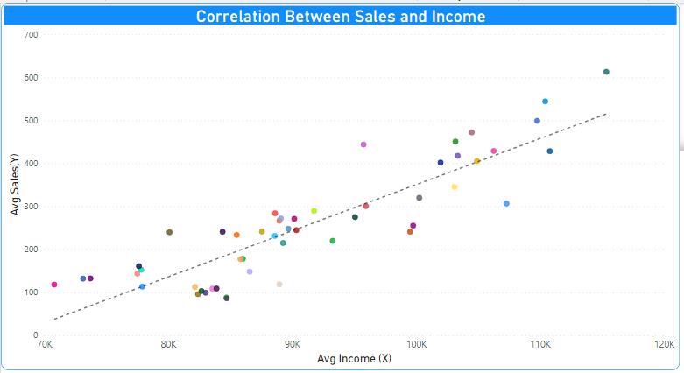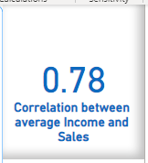

1. **What is the correlation (R2 value) between customer ratings and product return rate?**

The correlation between customer ratings and product return rate is 0.69 which is fairly strong. The trendline shows the likelihood of a product with a high rating been returned is fairly low and vice versa.

The following chart presents the scatterplot. And the card displays the correlation co-efficient (R2) calculated.

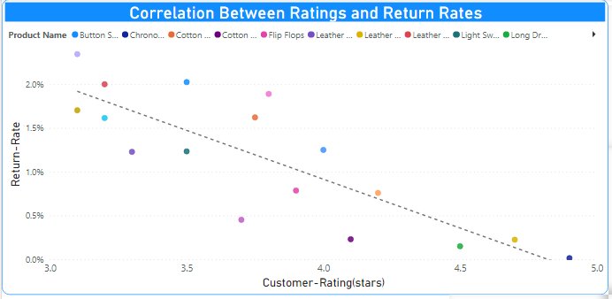

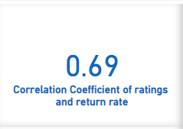

1. **What are the linear regression formulas to predict customer sales and customer incomes?**

For predicting customer sales, we use y = 0.0107x - 722.14

For predicting customer incomes, we use x = (-722.14 – y) / -0.0107

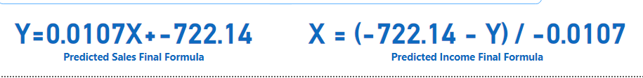

1. **Which customer do you predict has the highest income?**

The customer with the highest income is Jon Little from Illinois and born June 3 of 1984. He

purchases for $5250 in the last 6 months, his predicted income is $558143.



1. **Which product will be advertised the most?**

The most advertised product should be the sweater with a $100 price as majority of the customers purchases is between that price range.

